1. **How to execute CLI with Keys:**

**Install AWS CLI**

Sudo -i

sudo apt-get install -y python-dev python-pip

sudo pip install awscli

aws --version

aws configure

[AWS Access Key ID

AWS Secret Access Key

Default region name [us-west-2]

1. **How to execute CLI without Keys:**
2. Create a role with following:
   1. Assign IAM Policy IAMFullAccess “arn:aws:iam::aws:policy/IAMFullAccess”
   2. Trust Relation should have with ec2.amazonaws.com

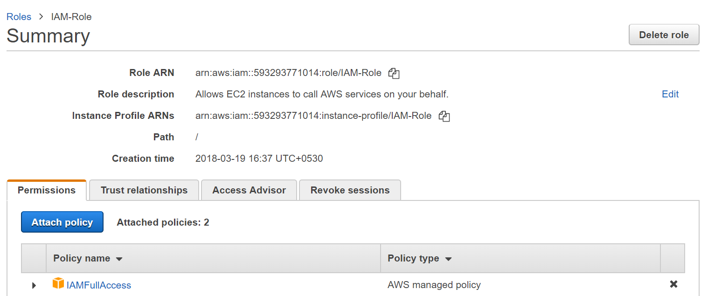

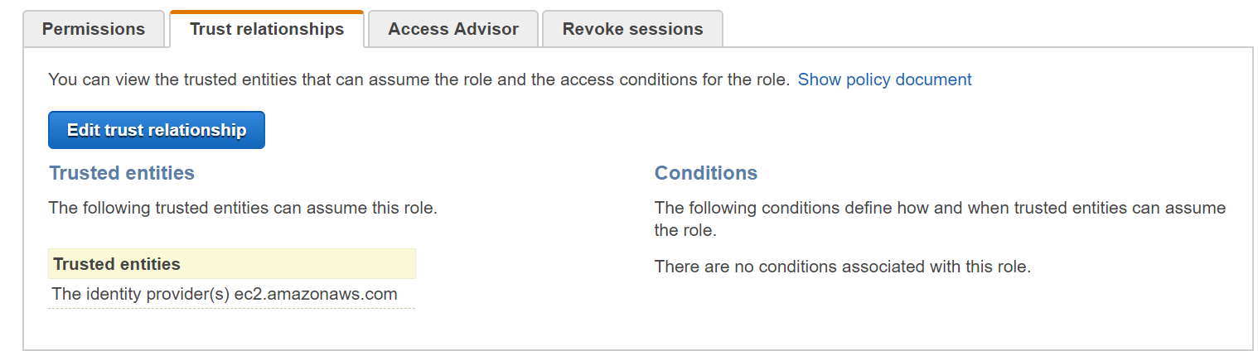

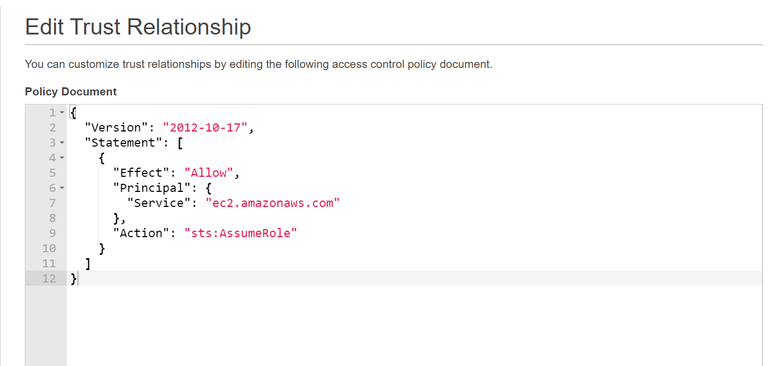

{

"Version": "2012-10-17",

"Statement": [

{

"Effect": "Allow",

"Principal": {

"Service": "ec2.amazonaws.com"

},

"Action": "sts:AssumeRole"

}

]

}

1. Attach this role with EC2 instance:

